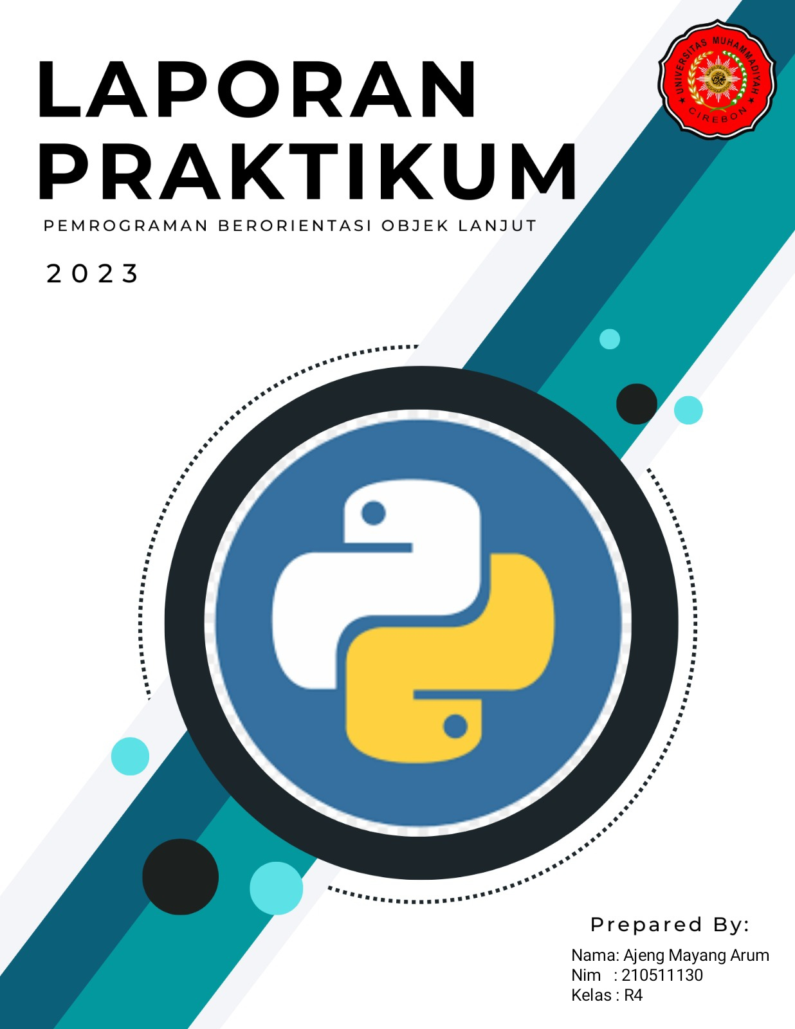

**Suara Anjing**

from playsound import *

class Animal:

    def make_sound(self):

        print("Mari dengarkan Suara")

class Anjing(Animal):

    def make_sound(self):

        print('Anjing')

        playsound('anjing.mp3')

class Kucing(Animal):

    def make_sound(self):

        print('Kucing')

        playsound('kucing.mp3')

class Ayam(Animal):

    def make_sound(self):

        print('Ayam')

        playsound('ayam.mp3')

class Gajah(Animal):

    def make_sound(self):

        print('Gajah')

        playsound('gajah.mp3')

class Kambing(Animal):

    def make_sound(self):

        print('Kambing')

        playsound('kambing.mp3')

class Kelelawar(Animal):

    def make_sound(self):

        print('Kelelawar')

        playsound('kelelawar.mp3')

class Sapi(Animal):

    def make_sound(self):

        print('Sapi')

        playsound('sapi.mp3')

class Serigala(Animal):

    def make_sound(self):

        print('Serigala')

        playsound('serigala.mp3')

class Burung(Animal):

    def make_sound(self):

        print('Burung')

        playsound('burung.mp3')

class Ular(Animal):

    def make_sound(self):

        print('Ular')

        playsound('ular.mp3')

def animal_sound(hewan):

    hewan.make_sound()

hewan = Animal()

anjing = Anjing()

kucing = Kucing()

sapi = Sapi()

ayam = Ayam()

gajah = Gajah()

kambing = Kambing()

kelelawar = Kelelawar()

serigala = Serigala()

burung = Burung()

ular = Ular()

animal_sound(hewan)

animal_sound(anjing)

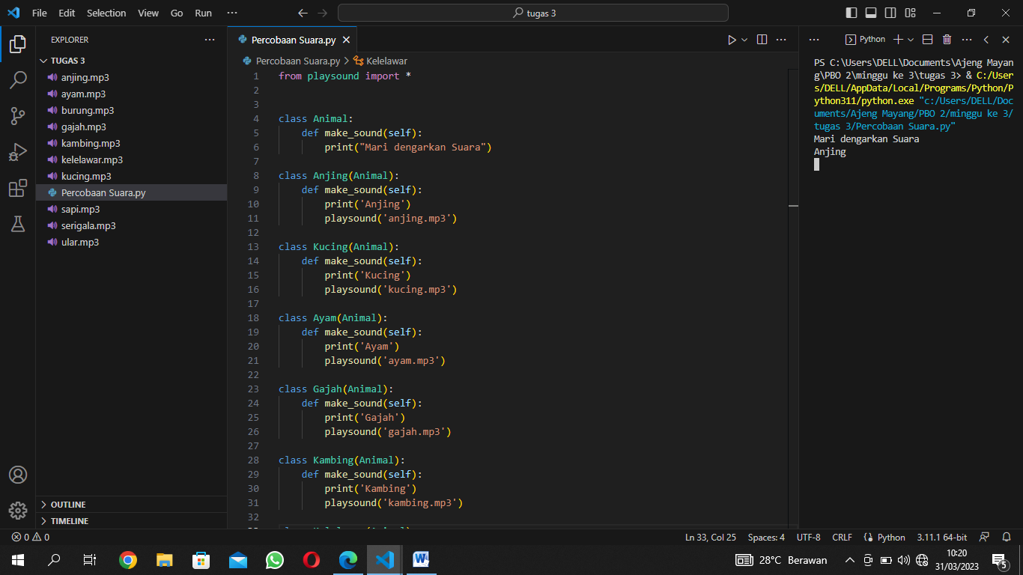

**Suara Ayam**

from playsound import *

class Animal:

    def make_sound(self):

        print("Mari dengarkan Suara")

class Anjing(Animal):

    def make_sound(self):

        print('Anjing')

        playsound('anjing.mp3')

class Kucing(Animal):

    def make_sound(self):

        print('Kucing')

        playsound('kucing.mp3')

class Ayam(Animal):

    def make_sound(self):

        print('Ayam')

        playsound('ayam.mp3')

class Gajah(Animal):

    def make_sound(self):

        print('Gajah')

        playsound('gajah.mp3')

class Kambing(Animal):

    def make_sound(self):

        print('Kambing')

        playsound('kambing.mp3')

class Kelelawar(Animal):

    def make_sound(self):

        print('Kelelawar')

        playsound('kelelawar.mp3')

class Sapi(Animal):

    def make_sound(self):

        print('Sapi')

        playsound('sapi.mp3')

class Serigala(Animal):

    def make_sound(self):

        print('Serigala')

        playsound('serigala.mp3')

class Burung(Animal):

    def make_sound(self):

        print('Burung')

        playsound('burung.mp3')

class Ular(Animal):

    def make_sound(self):

        print('Ular')

        playsound('ular.mp3')

def animal_sound(hewan):

    hewan.make_sound()

hewan = Animal()

anjing = Anjing()

kucing = Kucing()

sapi = Sapi()

ayam = Ayam()

gajah = Gajah()

kambing = Kambing()

kelelawar = Kelelawar()

serigala = Serigala()

burung = Burung()

ular = Ular()

animal_sound(hewan)

animal_sound(ayam)

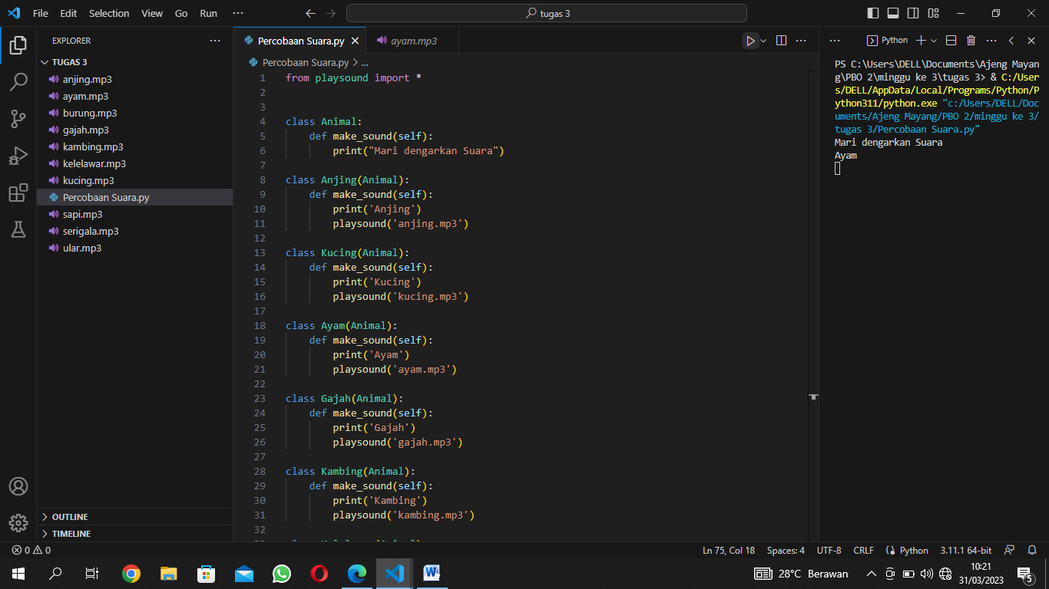

**Suara Burung**

from playsound import *

class Animal:

    def make_sound(self):

        print("Mari dengarkan Suara")

class Anjing(Animal):

    def make_sound(self):

        print('Anjing')

        playsound('anjing.mp3')

class Kucing(Animal):

    def make_sound(self):

        print('Kucing')

        playsound('kucing.mp3')

class Ayam(Animal):

    def make_sound(self):

        print('Ayam')

        playsound('ayam.mp3')

class Gajah(Animal):

    def make_sound(self):

        print('Gajah')

        playsound('gajah.mp3')

class Kambing(Animal):

    def make_sound(self):

        print('Kambing')

        playsound('kambing.mp3')

class Kelelawar(Animal):

    def make_sound(self):

        print('Kelelawar')

        playsound('kelelawar.mp3')

class Sapi(Animal):

    def make_sound(self):

        print('Sapi')

        playsound('sapi.mp3')

class Serigala(Animal):

    def make_sound(self):

        print('Serigala')

        playsound('serigala.mp3')

class Burung(Animal):

    def make_sound(self):

        print('Burung')

        playsound('burung.mp3')

class Ular(Animal):

    def make_sound(self):

        print('Ular')

        playsound('ular.mp3')

def animal_sound(hewan):

    hewan.make_sound()

hewan = Animal()

anjing = Anjing()

kucing = Kucing()

sapi = Sapi()

ayam = Ayam()

gajah = Gajah()

kambing = Kambing()

kelelawar = Kelelawar()

serigala = Serigala()

burung = Burung()

ular = Ular()

animal_sound(hewan)

animal_sound(burung)

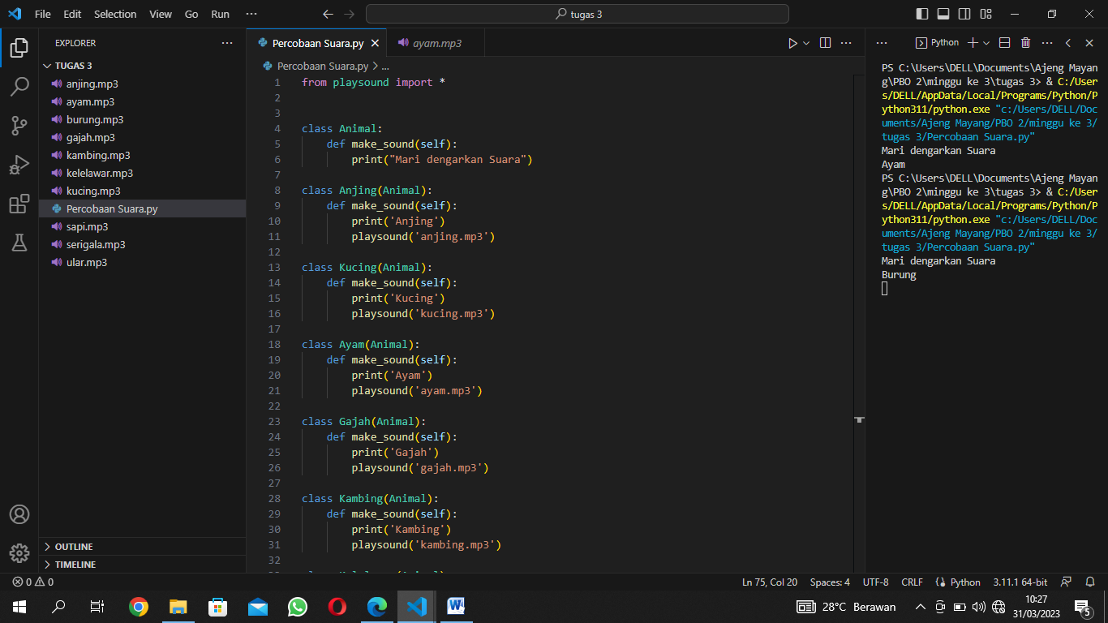

**Suara Gajah**

from playsound import *

class Animal:

    def make_sound(self):

        print("Mari dengarkan Suara")

class Anjing(Animal):

    def make_sound(self):

        print('Anjing')

        playsound('anjing.mp3')

class Kucing(Animal):

    def make_sound(self):

        print('Kucing')

        playsound('kucing.mp3')

class Ayam(Animal):

    def make_sound(self):

        print('Ayam')

        playsound('ayam.mp3')

class Gajah(Animal):

    def make_sound(self):

        print('Gajah')

        playsound('gajah.mp3')

class Kambing(Animal):

    def make_sound(self):

        print('Kambing')

        playsound('kambing.mp3')

class Kelelawar(Animal):

    def make_sound(self):

        print('Kelelawar')

        playsound('kelelawar.mp3')

class Sapi(Animal):

    def make_sound(self):

        print('Sapi')

        playsound('sapi.mp3')

class Serigala(Animal):

    def make_sound(self):

        print('Serigala')

        playsound('serigala.mp3')

class Burung(Animal):

    def make_sound(self):

        print('Burung')

        playsound('burung.mp3')

class Ular(Animal):

    def make_sound(self):

        print('Ular')

        playsound('ular.mp3')

def animal_sound(hewan):

    hewan.make_sound()

hewan = Animal()

anjing = Anjing()

kucing = Kucing()

sapi = Sapi()

ayam = Ayam()

gajah = Gajah()

kambing = Kambing()

kelelawar = Kelelawar()

serigala = Serigala()

burung = Burung()

ular = Ular()

animal_sound(hewan)

animal_sound(gajah)

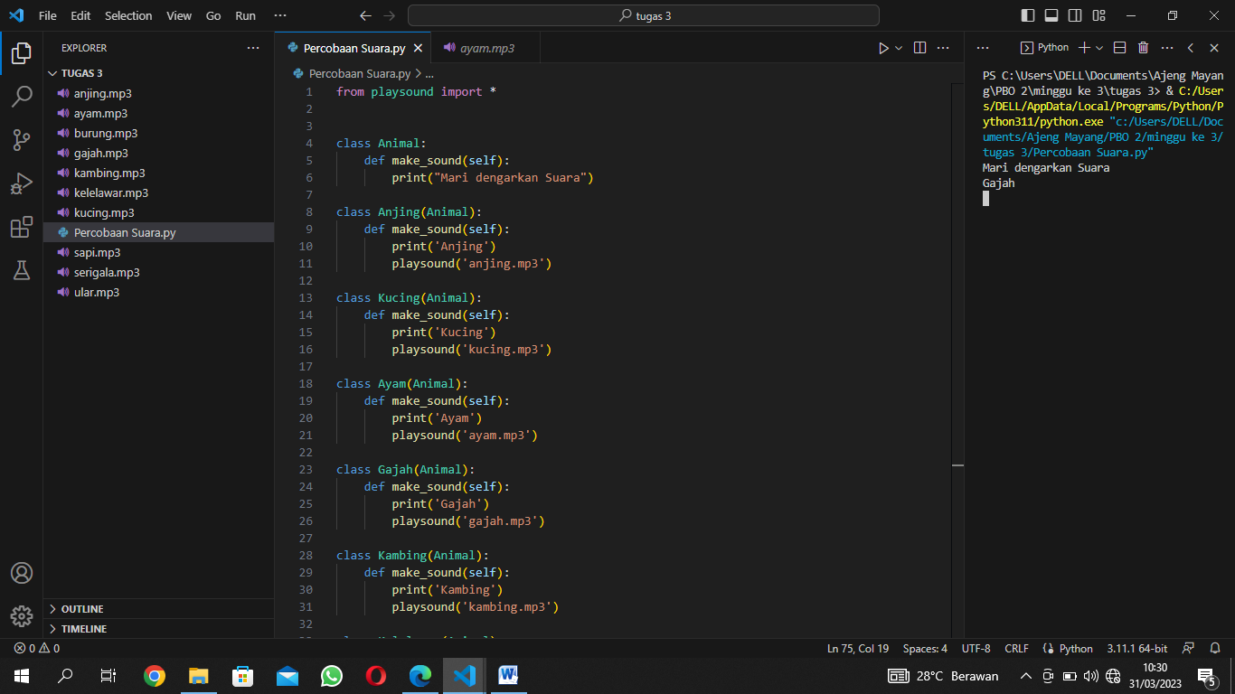

**Suara Kambing**

from playsound import *

class Animal:

    def make_sound(self):

        print("Mari dengarkan Suara")

class Anjing(Animal):

    def make_sound(self):

        print('Anjing')

        playsound('anjing.mp3')

class Kucing(Animal):

    def make_sound(self):

        print('Kucing')

        playsound('kucing.mp3')

class Ayam(Animal):

    def make_sound(self):

        print('Ayam')

        playsound('ayam.mp3')

class Gajah(Animal):

    def make_sound(self):

        print('Gajah')

        playsound('gajah.mp3')

class Kambing(Animal):

    def make_sound(self):

        print('Kambing')

        playsound('kambing.mp3')

class Kelelawar(Animal):

    def make_sound(self):

        print('Kelelawar')

        playsound('kelelawar.mp3')

class Sapi(Animal):

    def make_sound(self):

        print('Sapi')

        playsound('sapi.mp3')

class Serigala(Animal):

    def make_sound(self):

        print('Serigala')

        playsound('serigala.mp3')

class Burung(Animal):

    def make_sound(self):

        print('Burung')

        playsound('burung.mp3')

class Ular(Animal):

    def make_sound(self):

        print('Ular')

        playsound('ular.mp3')

def animal_sound(hewan):

    hewan.make_sound()

hewan = Animal()

anjing = Anjing()

kucing = Kucing()

sapi = Sapi()

ayam = Ayam()

gajah = Gajah()

kambing = Kambing()

kelelawar = Kelelawar()

serigala = Serigala()

burung = Burung()

ular = Ular()

animal_sound(hewan)

animal_sound(kambing)

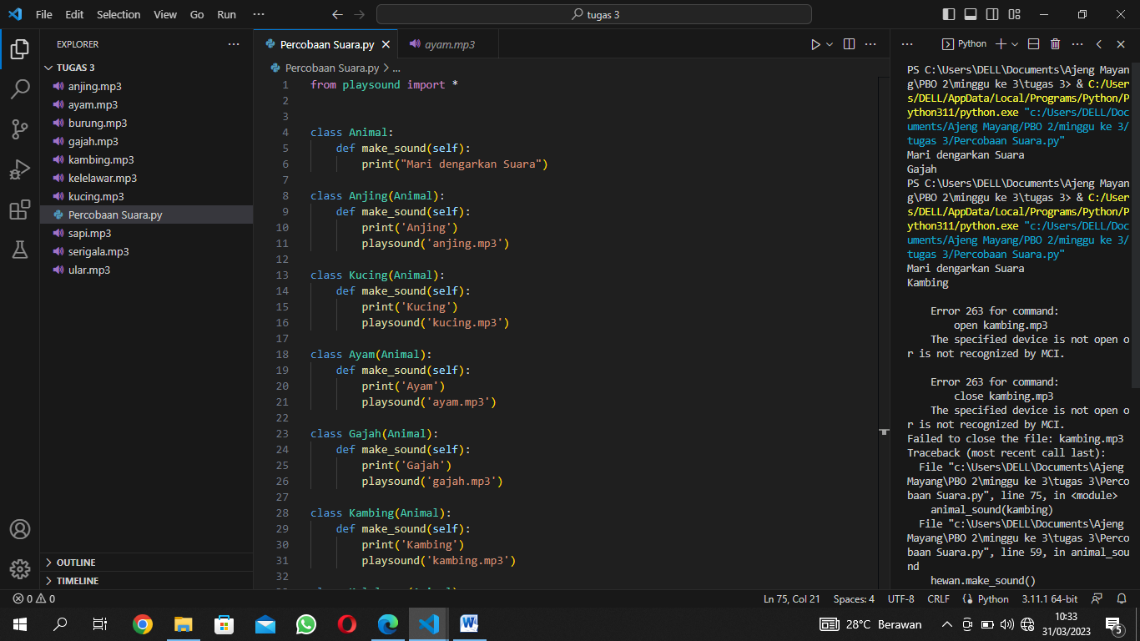

**Suara Kelelawar**

from playsound import *

class Animal:

    def make_sound(self):

        print("Mari dengarkan Suara")

class Anjing(Animal):

    def make_sound(self):

        print('Anjing')

        playsound('anjing.mp3')

class Kucing(Animal):

    def make_sound(self):

        print('Kucing')

        playsound('kucing.mp3')

class Ayam(Animal):

    def make_sound(self):

        print('Ayam')

        playsound('ayam.mp3')

class Gajah(Animal):

    def make_sound(self):

        print('Gajah')

        playsound('gajah.mp3')

class Kambing(Animal):

    def make_sound(self):

        print('Kambing')

        playsound('kambing.mp3')

class Kelelawar(Animal):

    def make_sound(self):

        print('Kelelawar')

        playsound('kelelawar.mp3')

class Sapi(Animal):

    def make_sound(self):

        print('Sapi')

        playsound('sapi.mp3')

class Serigala(Animal):

    def make_sound(self):

        print('Serigala')

        playsound('serigala.mp3')

class Burung(Animal):

    def make_sound(self):

        print('Burung')

        playsound('burung.mp3')

class Ular(Animal):

    def make_sound(self):

        print('Ular')

        playsound('ular.mp3')

def animal_sound(hewan):

    hewan.make_sound()

hewan = Animal()

anjing = Anjing()

kucing = Kucing()

sapi = Sapi()

ayam = Ayam()

gajah = Gajah()

kambing = Kambing()

kelelawar = Kelelawar()

serigala = Serigala()

burung = Burung()

ular = Ular()

animal_sound(hewan)

animal_sound(kelelawar)

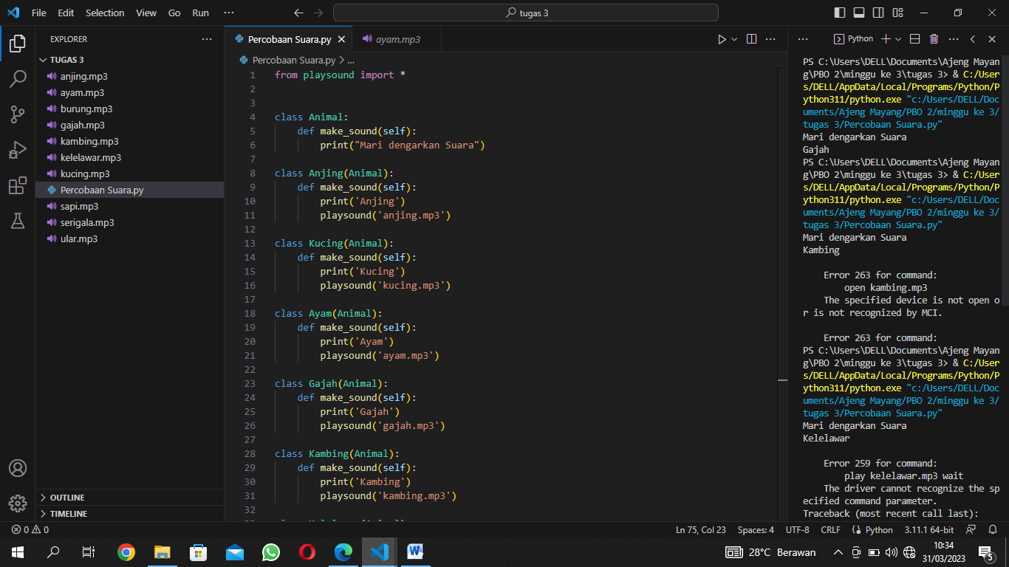

**Suara Kucing**

from playsound import *

class Animal:

    def make_sound(self):

        print("Mari dengarkan Suara")

class Anjing(Animal):

    def make_sound(self):

        print('Anjing')

        playsound('anjing.mp3')

class Kucing(Animal):

    def make_sound(self):

        print('Kucing')

        playsound('kucing.mp3')

class Ayam(Animal):

    def make_sound(self):

        print('Ayam')

        playsound('ayam.mp3')

class Gajah(Animal):

    def make_sound(self):

        print('Gajah')

        playsound('gajah.mp3')

class Kambing(Animal):

    def make_sound(self):

        print('Kambing')

        playsound('kambing.mp3')

class Kelelawar(Animal):

    def make_sound(self):

        print('Kelelawar')

        playsound('kelelawar.mp3')

class Sapi(Animal):

    def make_sound(self):

        print('Sapi')

        playsound('sapi.mp3')

class Serigala(Animal):

    def make_sound(self):

        print('Serigala')

        playsound('serigala.mp3')

class Burung(Animal):

    def make_sound(self):

        print('Burung')

        playsound('burung.mp3')

class Ular(Animal):

    def make_sound(self):

        print('Ular')

        playsound('ular.mp3')

def animal_sound(hewan):

    hewan.make_sound()

hewan = Animal()

anjing = Anjing()

kucing = Kucing()

sapi = Sapi()

ayam = Ayam()

gajah = Gajah()

kambing = Kambing()

kelelawar = Kelelawar()

serigala = Serigala()

burung = Burung()

ular = Ular()

animal_sound(hewan)

animal_sound(kucing)

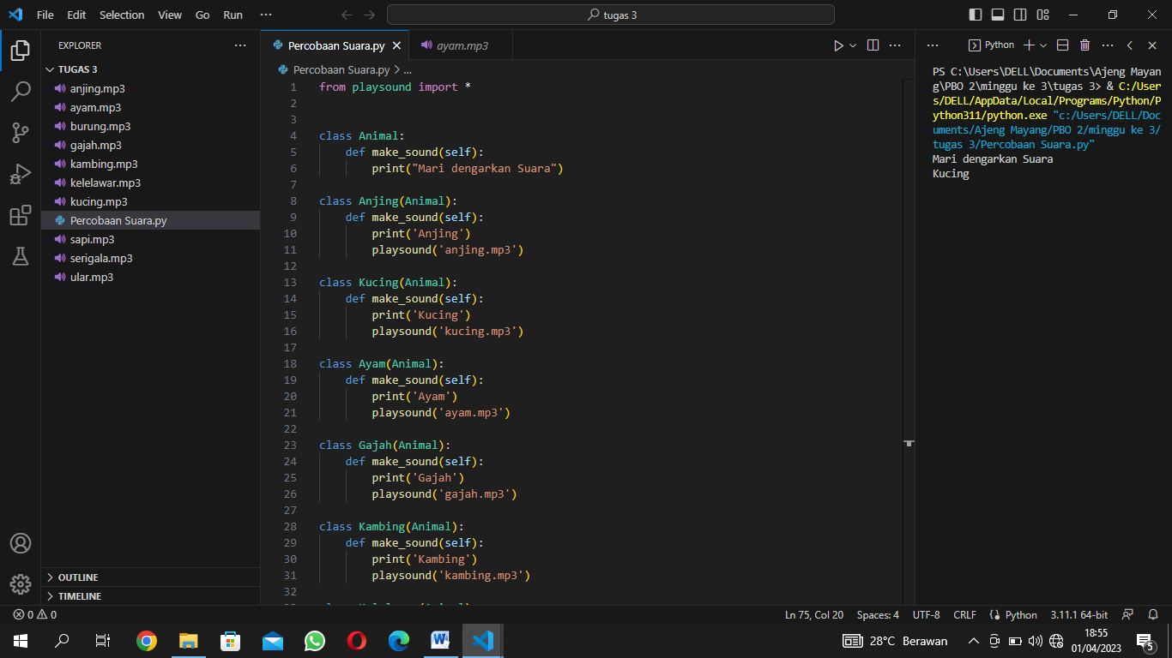

**Suara Sapi**

from playsound import *

class Animal:

    def make_sound(self):

        print("Mari dengarkan Suara")

class Anjing(Animal):

    def make_sound(self):

        print('Anjing')

        playsound('anjing.mp3')

class Kucing(Animal):

    def make_sound(self):

        print('Kucing')

        playsound('kucing.mp3')

class Ayam(Animal):

    def make_sound(self):

        print('Ayam')

        playsound('ayam.mp3')

class Gajah(Animal):

    def make_sound(self):

        print('Gajah')

        playsound('gajah.mp3')

class Kambing(Animal):

    def make_sound(self):

        print('Kambing')

        playsound('kambing.mp3')

class Kelelawar(Animal):

    def make_sound(self):

        print('Kelelawar')

        playsound('kelelawar.mp3')

class Sapi(Animal):

    def make_sound(self):

        print('Sapi')

        playsound('sapi.mp3')

class Serigala(Animal):

    def make_sound(self):

        print('Serigala')

        playsound('serigala.mp3')

class Burung(Animal):

    def make_sound(self):

        print('Burung')

        playsound('burung.mp3')

class Ular(Animal):

    def make_sound(self):

        print('Ular')

        playsound('ular.mp3')

def animal_sound(hewan):

    hewan.make_sound()

hewan = Animal()

anjing = Anjing()

kucing = Kucing()

sapi = Sapi()

ayam = Ayam()

gajah = Gajah()

kambing = Kambing()

kelelawar = Kelelawar()

serigala = Serigala()

burung = Burung()

ular = Ular()

animal_sound(hewan)

animal_sound(sapi)

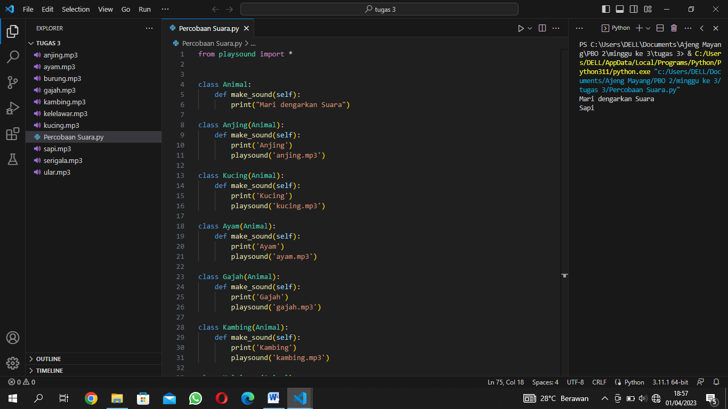

**Suara Serigala**

from playsound import *

class Animal:

    def make_sound(self):

        print("Mari dengarkan Suara")

class Anjing(Animal):

    def make_sound(self):

        print('Anjing')

        playsound('anjing.mp3')

class Kucing(Animal):

    def make_sound(self):

        print('Kucing')

        playsound('kucing.mp3')

class Ayam(Animal):

    def make_sound(self):

        print('Ayam')

        playsound('ayam.mp3')

class Gajah(Animal):

    def make_sound(self):

        print('Gajah')

        playsound('gajah.mp3')

class Kambing(Animal):

    def make_sound(self):

        print('Kambing')

        playsound('kambing.mp3')

class Kelelawar(Animal):

    def make_sound(self):

        print('Kelelawar')

        playsound('kelelawar.mp3')

class Sapi(Animal):

    def make_sound(self):

        print('Sapi')

        playsound('sapi.mp3')

class Serigala(Animal):

    def make_sound(self):

        print('Serigala')

        playsound('serigala.mp3')

class Burung(Animal):

    def make_sound(self):

        print('Burung')

        playsound('burung.mp3')

class Ular(Animal):

    def make_sound(self):

        print('Ular')

        playsound('ular.mp3')

def animal_sound(hewan):

    hewan.make_sound()

hewan = Animal()

anjing = Anjing()

kucing = Kucing()

sapi = Sapi()

ayam = Ayam()

gajah = Gajah()

kambing = Kambing()

kelelawar = Kelelawar()

serigala = Serigala()

burung = Burung()

ular = Ular()

animal_sound(hewan)

animal_sound(serigala)

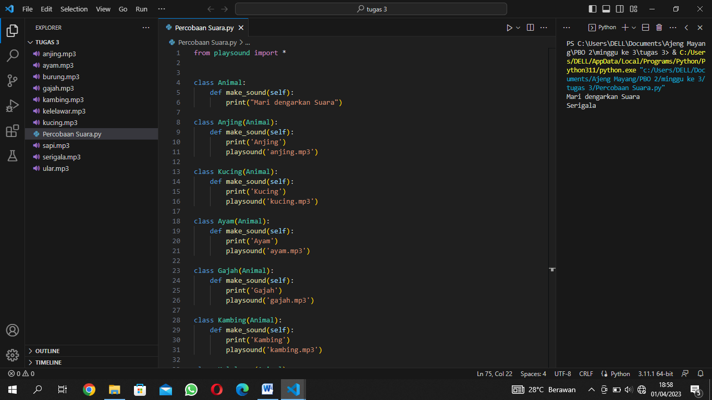

**Suara Ular**

from playsound import *

class Animal:

    def make_sound(self):

        print("Mari dengarkan Suara")

class Anjing(Animal):

    def make_sound(self):

        print('Anjing')

        playsound('anjing.mp3')

class Kucing(Animal):

    def make_sound(self):

        print('Kucing')

        playsound('kucing.mp3')

class Ayam(Animal):

    def make_sound(self):

        print('Ayam')

        playsound('ayam.mp3')

class Gajah(Animal):

    def make_sound(self):

        print('Gajah')

        playsound('gajah.mp3')

class Kambing(Animal):

    def make_sound(self):

        print('Kambing')

        playsound('kambing.mp3')

class Kelelawar(Animal):

    def make_sound(self):

        print('Kelelawar')

        playsound('kelelawar.mp3')

class Sapi(Animal):

    def make_sound(self):

        print('Sapi')

        playsound('sapi.mp3')

class Serigala(Animal):

    def make_sound(self):

        print('Serigala')

        playsound('serigala.mp3')

class Burung(Animal):

    def make_sound(self):

        print('Burung')

        playsound('burung.mp3')

class Ular(Animal):

    def make_sound(self):

        print('Ular')

        playsound('ular.mp3')

def animal_sound(hewan):

    hewan.make_sound()

hewan = Animal()

anjing = Anjing()

kucing = Kucing()

sapi = Sapi()

ayam = Ayam()

gajah = Gajah()

kambing = Kambing()

kelelawar = Kelelawar()

serigala = Serigala()

burung = Burung()

ular = Ular()

animal_sound(hewan)

animal_sound(ular)

